An advisory commission of the Coastal Protection and Restoration Authority
cOASTAL LOUISIANA LEVEE CONSORTIUM

Amite River Basin Drainage and Water Conservation District

Atchafalaya Basin Levee District

Office of the Governor-Coastal Activities

Chenier Plain Coastal Restoration & Protection Authority

Grand Isle Independent Levee District

Iberia Parish Levee District

Jefferson Davis Parish Government

Lafitte Area Independent Levee District

Lafourche Basin Levee District

Non-Flood Protection Asset Management Authority

North Lafourche Conservation, Levee and Drainage District

Plaquemines Parish Government

Pontchartrain Levee District

The Sewerage and Water Board of New Orleans

South Lafourche Levee District

Southeast Louisiana Flood Protection Authority—East

Southeast Louisiana Flood Protection Authority—West

St. Mary Levee District

St. Tammany Levee District

Terrebonne Levee and Conservation District

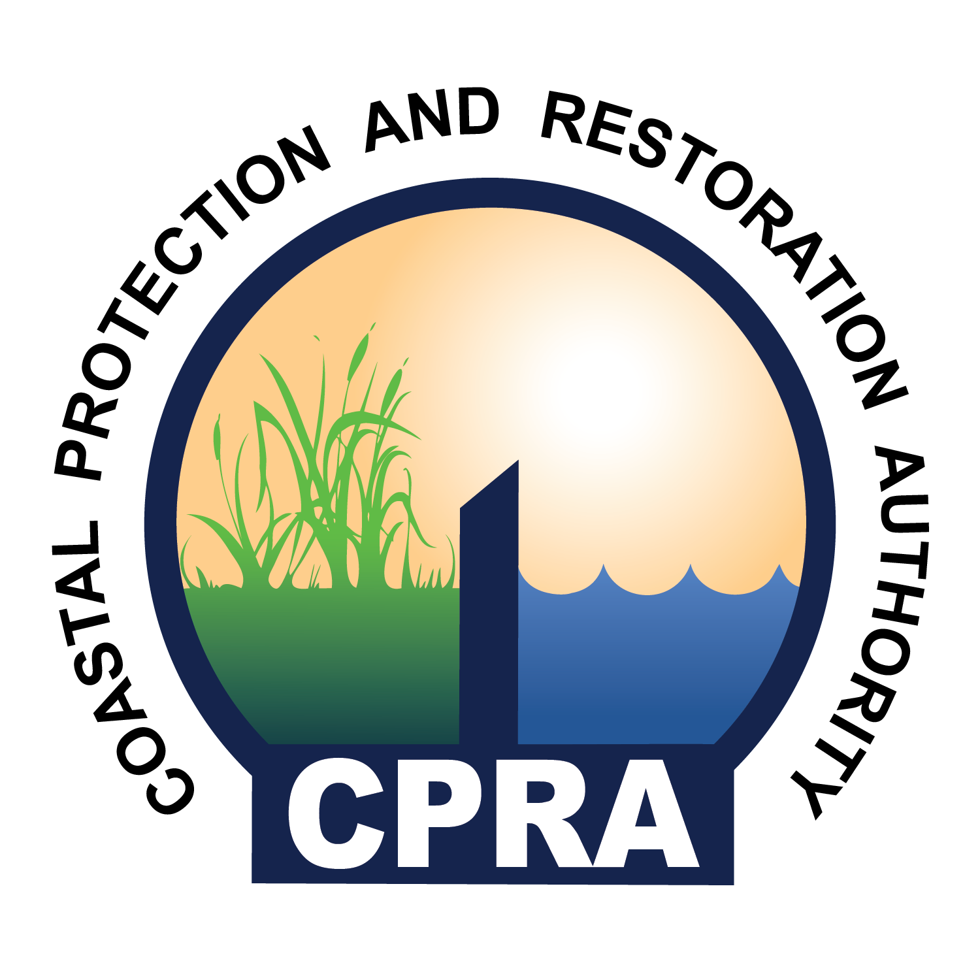

The meeting of the
Coastal Louisiana Levee Consortium
has been scheduled for:

Tuesday, September 8, 2020
State Capitol – House Committee Room 5
900 North Third Street
Baton Rouge, LA 70802
9:30 am

If you need further information, please call
The North Lafourche Levee District at: (985) 537-2244

