REGIONAL TRANSIT AUTHORITY
OPERATIONS AND ADMINISTRATION COMMITTEE
2817 CANAL STREET
RTA BOARD ROOM, SECOND FLOOR
NEW ORLEANS, LA 70119
THURSDAY, AUGUST 15, 2019 AT 10:00 A.M.

COMMITTEE MEMBERS PRESENT: Chairman Fred Neal, Jr, Commissioner Walter Tillery and Commissioner Sharon Wegner

APPROVAL OF MINUTES – JUNE 13, 2019

Commissioner Tillery moved and Commissioner Wegner seconded to approve the minutes of June 13, 2019. Verbal Motion 19-076 was approved unanimously.
COMMITTEE CHAIRMAN’S REPORT
Chairman Neal reported that there was a lot going on behind the scenes; the new CEO that was working on finalizing the Operations and Maintenance Contract.
COMPREHENSIVE OPERATIONS ANALYSIS (COA)
Samuel Buckley reported that New Links and staff have been doing a lot of field work and the consultants were in town last week doing on the ground field work and holding public meetings.
Samuel Buckley reported that the last 3 meetings were going to take place: on Monday in Jefferson Parish on the East Bank Library; Tuesday’s meeting will be held at the Kenner Heritage Hall; Thursday’s Meeting will be at the Jazz and Heritage Foundation on Rampart.
Samuel Buckley reported that staff was starting to move into the Domain Analysis of the Comprehensive Operations Analysis and moving towards development of the different scenarios and he wanted to encourage everyone to come out to the final public meetings on Thursday.
Chairman Neal stated that he wanted to reiterate that this is a very important process that the RTA was taking on in partnership with the Regional Planning Commission, Jefferson Transit and St. Bernard Parish and this is a regional project with more community meetings in the fall.
Chairman Neal stated that if anyone in the audience wished to speak, please make sure you fill out a comment sheet so you can speak during Audience Questions and Comments.
OPERATIONS REPORT
TITLE VI
Adelee Le Grand stated that the following is why the RTA has to conduct a Title VI:
Title VI of the Civil Rights Act of 1964 prohibits discrimination on the basis of race, color, or national origin in programs and activities receiving Federal financial assistance. Title VI provides that no person in the United States shall, on the ground of race, color, or national origin, be excluded from participation in, be denied the benefits of, or be subjected to discrimination under any program or activity receiving Federal financial assistance from the U.S. Department of Transportation.

Percent Minority and Low-Income Data

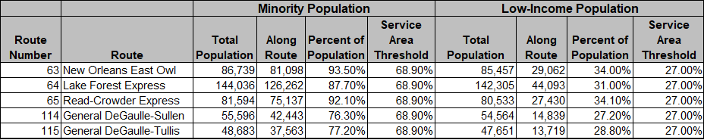

System-Wide Served Data

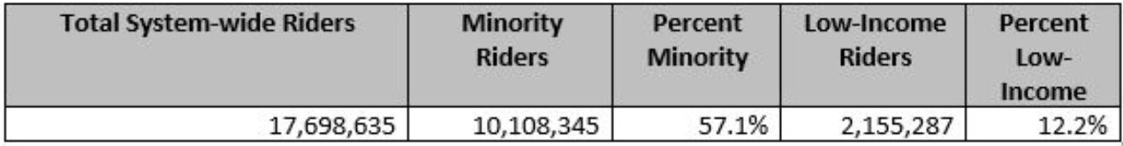
SERVICE ENHANCEMENTS
  - 63 - One change will take affect:
    - Increase frequency from 60 minutes to 30 minutes
  - 64/65 - Three changes will take affect:
    - Eliminate weekday interlining of the 64/65
    - Expand service to 30-minute frequency for the entire service day
    - Reduce 65 route duration by 20 minutes
  - 114/115 - One change will take affect:
    - Increase frequency from 45 minutes to 25 - 30 minutes during peak periods.
  - Algiers Point - Canal St. Ferry - One change will take affect:
    - Begin service at 6:00 am daily, instead of 10:30 am on weekends
63-NEW ORLEANS EAST OWL
In the analysis of the service change to line 63 New Orleans East Owl - will decrease wait times by 50%. This is an overnight service, riders would no longer have to wait 60 minutes for the bus. The bus will come every 30 minutes with the improvements.
64-LAKE FOREST EXPRESS
In the analysis of the service change to line 64 Lake Forest Express - will decrease wait times by 28%. The change will increase midday and evening service on the line. The 64 currently operates at 30-minute headways only during AM and PM peak hours and operates hourly for the rest of the service day. The bus will come every 30 minutes with the improvements.
65-READ-CROWDER EXPRESS
In the analysis of the service change to line 65 Read-Crowder Express - will decrease wait times by 29%. The change will increase midday and evening service on the line. The 64 currently operates at 30-minute headways only during AM and PM peak hours and operates hourly for the rest of the service day. The bus will come every 30 minutes with the improvements.
114-GENERAL DEGAULLE-SULLEN
In the analysis of the service change to line 114 General DeGaulle-Sullen - will decrease wait times by 27%. The 114 currently operates at 45-minute headways throughout the day and will continue during off peak times. The change will increase peak service only with 30-minute headways. The bus will come every 30 minutes during peak time only with the improvements. The below average time changes are reflected during peak and off-peak times.
115-GENERAL DEGAULLE-TULLIS
In the analysis of the service change to line 115 General DeGaulle-Tullis - will decrease wait times by 29%. The 115 currently operate at 45 to 50-minute headways throughout the day and will continue during off peak times. The change will increase peak service only with 30-minute headways. The bus will come every 30 minutes during peak time only with the improvements. The below average time changes are reflected during peak and off-peak times.

PUBLIC INVOLVEMENT

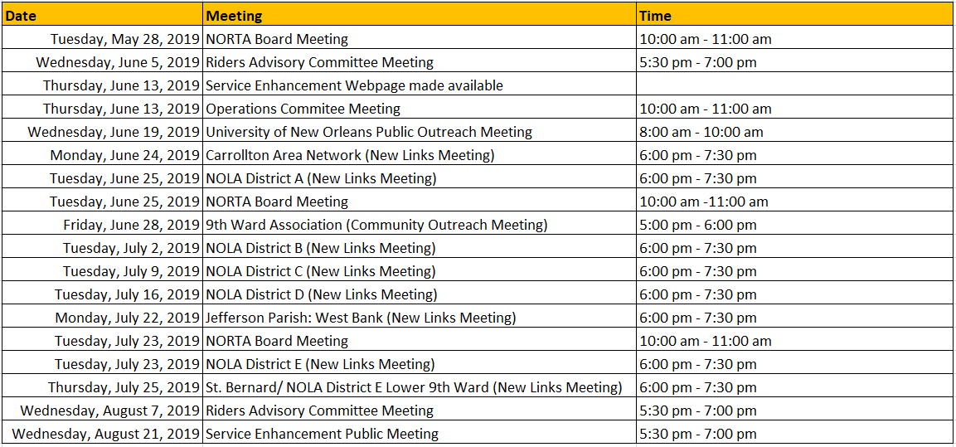

COMMUNITY FEEDBACK
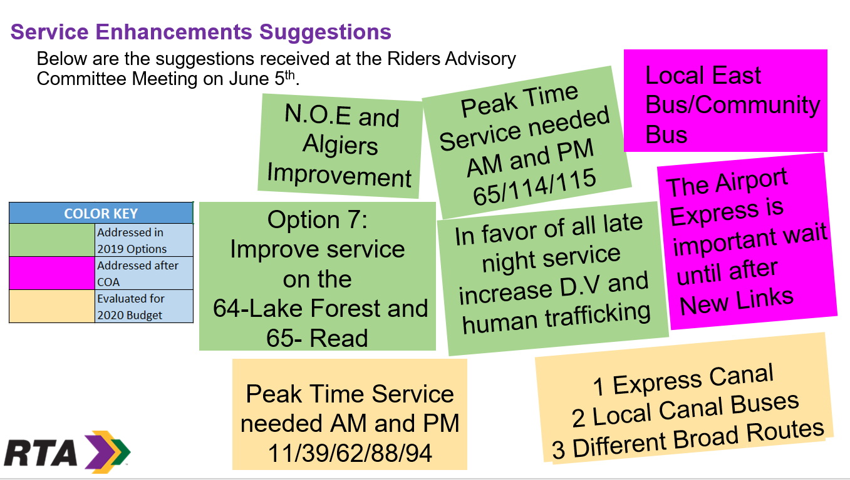

COMMUNITY FEEDBACK

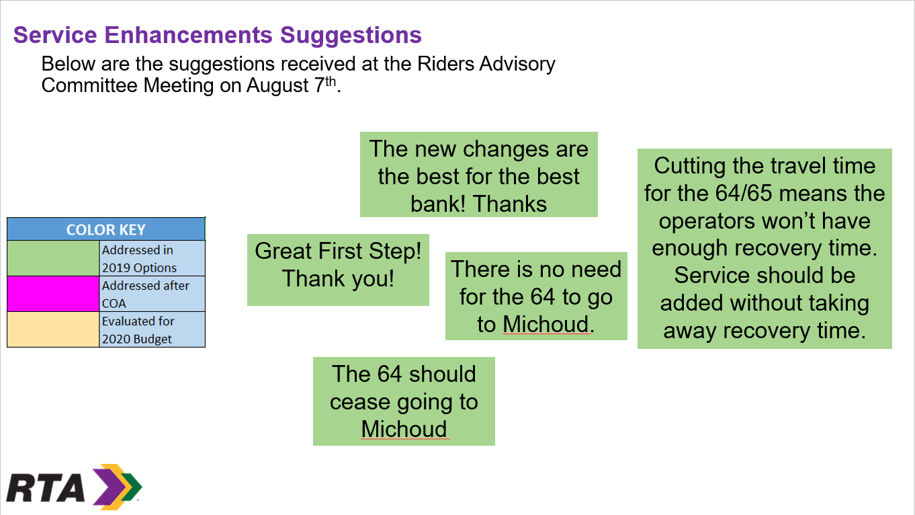
COMMUNITY FEEDBACK

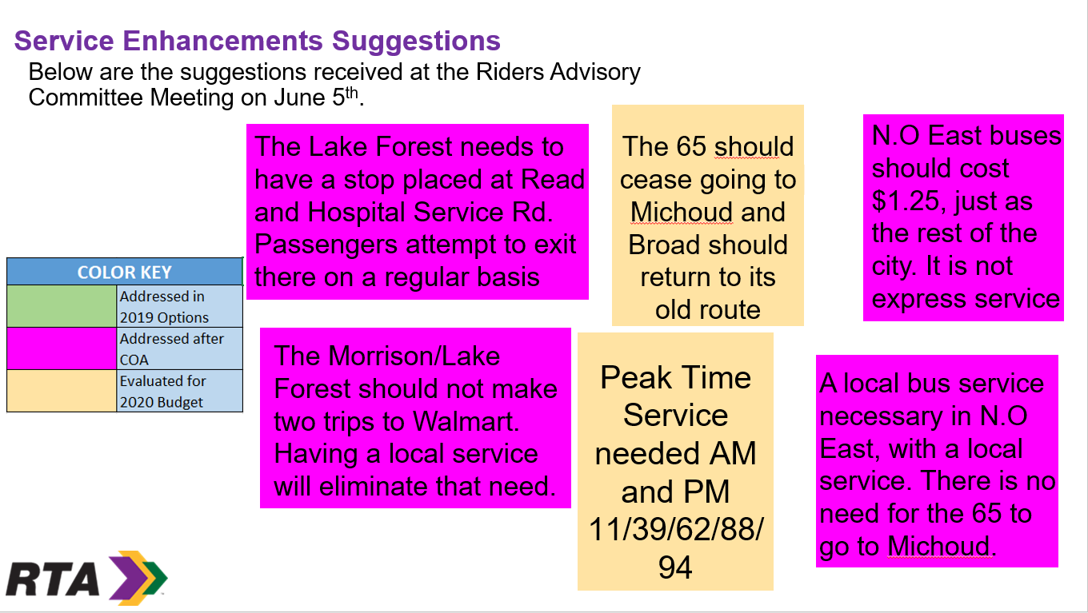

SUMMARY OF SERVICE CHANGES

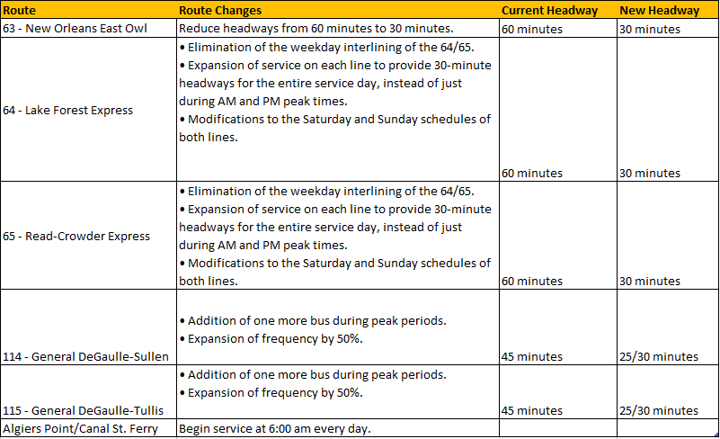
CONCLUSION
There was no unequal impact to minority populations or unequal burden to low-income populations. The low-income and minority populations with access to the impacted Bus Lines 63 - New Orleans East Owl, 64 - Lake Forest Express, 65 - Read-Crowder Express, 114 - General DeGaulle-Sullen, 115 - General DeGaulle-Tullis will have a travel time improvement, reduced wait times and an overall shorter commute
Chairman Neal thanked Adelee Le Grand and her team for the hard work that was done on this project.
In response to Chairman Neal, Adelee Le Grand stated that through Title VI these changes provide better service in the short term to the communities that are transit dependent and Title VI also supports what the RTA needs to do federally.
In response to Commissioner Wegner, Adelee Le Grand stated that she would provide her with the budget for the Service Enhancements.
Chairman Neal stated that he has discussed with Mark Major the process of building the budget for next year by making sure that all these changes are reflected moving forward.
Mark Major stated that there are some cost data being incorporated in the 2019 budget that will be brought before the board.
In response to Commissioner Wegner, Mark Major stated that the Board was presented with 19 options but did not formally adopt any of these options and once they receive the list of Service Enhancements it will be included in the restated 2019 budget which is based on September 1, 2019 through December 31st 2019.
Chairman Neal stated that the Service Enhancements were adopted as part of the overall budget but were not implemented in the budget number that was approved.
SERVICE ENHANCEMENTS EQUITY ANALYSIS
Deslie Isidore stated that staff was asking to approve the Service Enhancements Equity Analysis.
Commissioner Wegner moved and Commissioner Tillery seconded to approve the Service Enhancements Equity Analysis. Verbal Motion No. 19-077 was approved unanimously.
Fixed Route – July
- There were 1.8 accidents per 100,000 miles on Fixed Route.
- On Time Performance was 78.8%
- Miles between Road Calls were 77,618
- Boardings Per Hour were 20. 1
Streetcars - July
- There were 7.0 accidents per 100,000 miles
- On-Time Performance – 61.1%
- Miles Between Road Calls – (Check number to make sure it is accurate)
- Boardings Per Hour were 35.9
Ferry – July
- Ridership for the ferry for was 68,405
- 94.8 % Reliability
Paratransit – July
- There were 0 accidents per 100,000 miles
- On Time Performance – 90.6%
- Miles between Road Calls – (Check number to make sure it is accurate)
- Boarding Per Hour were 1.6
- Call Center Missed Calls 8.6%
- Call Center Average Time on Hold 1:57
In response to Chairman Neal, Darryll Simpson stated that staff has thought about ways to monitor and maintain performance measurements knowing that there is a split form of transportation on the St. Charles Line; staff has to make sure that everything that has failed in the field was calculated if it disrupts service and you will have a lot of field disruptions that have to be properly be calculated.
Darryll Simpson reported that there has been an uptick in accidents that has to be addressed and as a part of the transition plan on September 1, 2019, a 10-hour session of retraining with the operators will involve customer service and safety and this will be captured as a part of our normal safety meetings where staff can emphasize the importance of safety and staying a good distance away from any encroachment and I think there is a behavior of the streetcars having the right-of-way but in a mixed use environment, like in New Orleans these is not a good thing..
Darryll Simpson reported that staff may implement the SMITH Training for the operators.
Darryll Simpson reported that the construction on St. Charles was moving along extremely well and he was amazed to see how much they have achieved in 2 weeks and hopefully this project will be completed as planned.
Darryll Simpson reported that two bus bridges were put in for the St. Charles Streetcar Line to deal with the numerous festivals and Mardi Gras.
CAPITAL PROJECTS UPDATE

- Canal Street Ferry Terminal + Riverfront Streetcar Upriver Connector Bus Stop
- The 60% design was delivered by the Engineer of record on August 6, 2019.
- The CMAR Contractor will now work on the 60% design estimate.
- The RTA will be receiving the first independent cost estimate which will help validate the CMAR estimate.
- A meeting will take place in Algiers Point to present the 60% design to get feedback from the public
- A meeting will take place on Wednesday, August 21, 2019; a presentation will take place in front of the Design Advisory Committee
- This week several big meetings were held with potential subcontractors to make sure that all companies that are looking at this project have a clear understanding of the scope of work to receive competitive numbers.

2. Algiers Ferry Terminal Rehabilitation – Section 106 Review (environmental)
- A pre-proposal meeting was held with all three SBE On-Call A&E Firms was held on July 15, 2019
- All proposals were due and received on July 30, 2019
- The Infrastructure Department has evaluated all three proposals and is in the process of requesting more information for clarifications. It is the goal to have the best value proposal selected by the end of August and ask the RTA Board for authorization to assign the task order during the September Board Meeting.

- Riverfront Streetcar Line Special Trackwork Replacement and OCS Poles painting and St. Charles Streetcar Line Special Trackwork Replacement
- Working on a design with the fabrication
- Delivery of the track is expected in early 2020.

- Napoleon Facility Renovation
- The mandatory pre-bid conference/DBE outreach meeting and the site visit took place on August 1, 2019 with very good contractor participation
- The bid opening was scheduled for August 19, 2019.

- Algiers Park & Ride Rehabilitation – Phase 1
- All work has been completed

- A. Philip Randolph and ENO Facilities – Exterior Envelope Repairs
- Randolph Facility is 45% complete as of this date.
- ENO Facility is 70% completed as of this date.
- Both projects should be completed by October, 2019.

- St. Charles Streetcar Line OCS Poles Repair
- The contraction started on July 22, 2019 and is currently 40% completed
- 9 out of 13 new poles have been set in place
- The OCS System has been transferred onto 2 new OCS pole arms.

- St. Charles Streetcar Line Downtown Loop Track Pavement Replacement
- The actual construction started on August 5, 2019.
- The contractor has already removed the existing track pavement in the first block of St. Charles Avenue.
- The first concrete pavement placement was completed on August 8, 2019.
- It appears that the construction will progress faster than anticipated and the staff want to extend the project limits with the same contractor up to the 100% utilization of our budgetary resources pending the contract continues to perform well.

- St. Charles Streetcar Line ADA Modifications
- The DPW selected Hard Rock Construction as the On-Call Contractor to perform this work.
- We are currently awaiting DPW’s NTP which is anticipated to be issued in August 2019.

EXECUTIVE MANAGEMENT REPORT
In response to Chairman Neal, Darryll Simpson stated that staff has talked about having an Algiers Loop bus that will stay on the westbank and meet up with other routes at the Algiers Park-N-Ride and those routes would take the passengers to the eastbank.
In response to Commissioner Wegner, Darryll Simpson stated that there is currently a Safety Bonus Plan in place.
In response to Commissioner Wegner, Darryll Simpson stated that approximately 450 operators received a $500 Bonus last year and he will revisit the Safety Bonus Plan with the Safety Department.
In response to Commissioner Wegner, Darryll Simpson stated that an operator will be terminated after 3 accidents during a certain period of time.
In response to Commissioner Wegner, Darryll Simpson stated that operators have to come to work, feel good about being at work and have a great working environment because we’re operating historic streetcars, some without air conditioning.
Darryll Simpson stated that he has had talks with Valerie Jefferson about mitigating some accidents so they will not be chargeable accidents.
Darryll Simpson stated that the Customer Service Call Center Missed Calls were 5.1%; Average Time on Hold 00:16; Time to Close Complaints 3.6 days.
GoMobile 2.0 Data – July 2019
- Active users in July 2019: 17,734 (down 750 from June)
- Tickets and passes sold in July 2019 on GoMobile
  - 64,515
  - Total revenue: $182,128.05
- Top 3 Ticket/Pass Types Sold on GoMobile in July 2019
  - Single-Ride Fare
  - 1-Day Jazzy Pass
  - Single-Ride Fare with Transfer
- 1,022 Regional Ride fares sold on GoMobile in July 2019

PUBLIC INFORMATION
Deslie Isidore stated that the Public Information Report can be found in the meeting folder.
RTA CHIEF EXECUTIVE OFFICER’S REPORT
Alex Wiggins reported that staff was making great progress with contract negotiations and a meeting was scheduled for today and he hoped to wrap things up soon
Alex Wiggins reported that Jennifer Fehribach was going to be the new Chief Operations Officer and she is coming to the RTA from Texas where she has worked at both Houston Metro and at Corpus Christi and she has a very impressive background and she will start in September.
Alex Wiggins reported that he hired a Chief of Staff which will be his front line person that will work with elected officials and RTA’s Stake Holders across the region and she understands the priorities across the parishes and will champion the RTA’s efforts to build both local, state and federal agendas.
Chairman Neal stated that the State was having a press conference today to discuss the Superdome Exposition District and it would be great to know how transit fits in the big picture
AUDIENCE QUESTIONS AND COMMENTS
In response to Fred Robertson, Mark Major stated that the RTA was soliciting for a Financial Advisor and the 2010 Bonds could not be refinanced until 2020 and the RTA would like to enjoy the lower interest rates.
In response to Fred Robertson, Mark Major stated that the RTA was looking to refinance the outstanding principle and was not looking to add additional money on that transaction and in today’s environment and if this holds true into 2020, the RTA will be able to refinance those bonds at something less than 5%.
In response to Fred Robertson, Mark Major stated that he was willing to meet with Fred Robertson and give him more details.
NEW BUSINESS (UNANIMOUS VOTE REQUIRED TO CONSIDER)
None

ADJOURNMENT
Commissioner Tillery moved and Commissioner Wegner seconded to adjourn the Operations and Administration Meeting on August 15, 2019 at 11:04 a.m. Verbal Motion No. 19-078 was approved unanimously.

