Atchafalaya Trace Commission Regular Meeting
Wednesday, November 8, 2017 • 10:00 AM
Capitol Park Welcome Center, 702 North River Road, Baton Rouge, LA

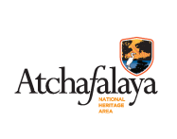

AGENDA

Call to Order/Pledge of Allegiance

- Agenda Approval

- Approval of 9/13/17 Regular Meeting Minutes

- Administrative Report, Budget Update
and Outreach Activities Steven Fullen

- Projects’ Progress Report

- Committee Activity Reports
- Natural & Outdoor Resources
- Atchafalaya Basin Update
- Education
- History & Culture
- Sustainability

- Other Business

- Commissioner Announcements

- Adjourn

