Scope of Work
Contractor shall provide all labor and materials in order to remove and install new control/communication equipment for the campus’s water tower and well site controls.

Location
Eastern Louisiana Mental Health System
4502 Hwy 951
Jackson, LA 70748

Mandatory site visit contacts
Jonathan Holley 225-634-0202 jonthan.holley@la.gov
Dylan Furys 225-634-0325 dylan.fury@la.gov

Specifications
Contractor shall:
- Provide and install new communication/control equipment at both the water tower and well sites.
- Provide and install two (2) weatherproof enclosures at both the well and tower site
- Provide and install two (2) back plates for the enclosures at both the well and tower site
- Provide and install two (2) programmable logic controllers (PLCs) at both the well and tower site
- Provide and install one (1) analog output card at well site and one (1) analog input card at the tower site
- Provide and install two (2) radios at both the well and tower site
- Provide and install two (2) AC surge protectors at both the well and tower site
- Provide and install two (2) circuit breakers at both the well and tower site
- Provide and install two (2) 120v receptacles at both the well and tower site
- Provide and install two (2) 24vDC power supplies at both the well and tower site
- Provide and install two (2) coax surge protectors at both the well and tower site
- Provide and install one (1) Analog surge protector at tower site
- Provide and install two (2) Yagi antennas at both the well and tower site
- Provide and install two (2) patch cables at both the well and tower site
- Provide and install one (1) level indicator at well site
- Provide and install one (1) level transmitter at tower site
- Provide and install two (2) panelview cables at both the well and tower site
- Provide and install one (1) phone dialer at well site

Newly Installed Equipment shall be equal to the following:
Well Site
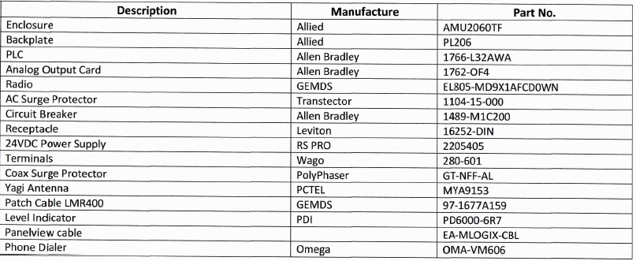

Tower Site
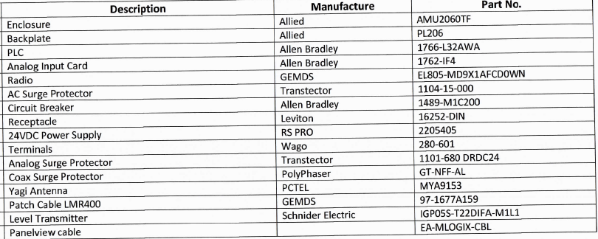

Specify Brand/Model of Parts Bidding
Well Site:
Part Description | State Brand/Model Bidding
Enclosure
Backplate
PLC
Analog Output Card
Radio
AC Surge Protector
Circuit Breaker
Receptacle
24VDC Power Supply
Terminals
Coax Surge Protector
Yagi Antenna
Patch Cable
Level Indicator
Panelview Cable
Phone Dialer

Tower Site
Part Description | State Brand/Model Bidding
Enclosure
Backplate
PLC
Analog Output Card
Radio
AC Surge Protector
Circuit Breaker
Receptacle
24VDC Power Supply
Terminals
Analog Surge Protector
Coax Surge Protector
Yagi Antenna
Patch Cable LMR400
Level Transmitter
Panelview Cable

General Terms and Conditions
- The work shall be performed during normal business hours of 7:00a.m – 3:30p.m Monday – Friday
- Contractors are subject to daily vehicle checks
- All waste shall be removed from the work site daily and disposed within the right measures including property control. All waste shall also be assessed by the appropriate staff before it is removed from the site.
- Contractor representatives shall follow all State policy and procedures while preforming work on the facility grounds.
- Work to be performed in a workmanlike manner according to standard, and meet all code requirements, federal , state and local

