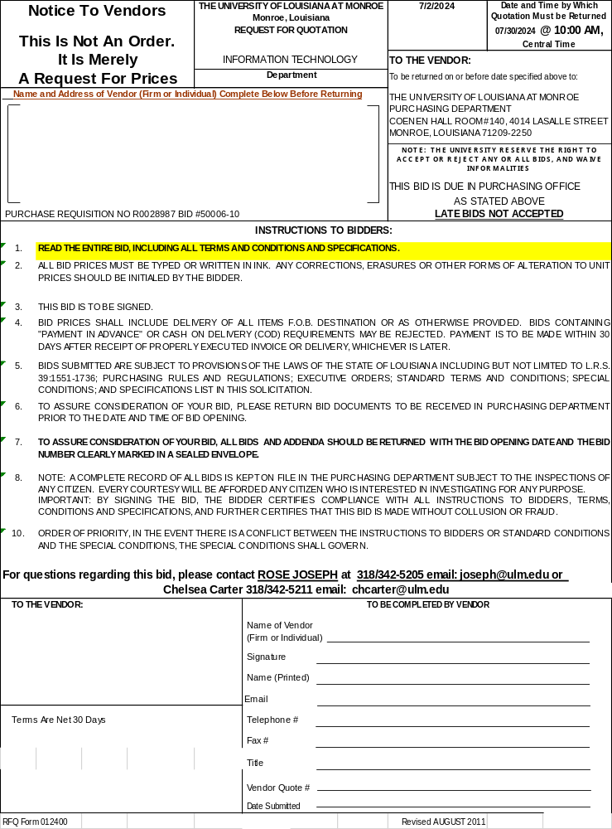

“ADVERTISEMENT FOR BIDS

Sealed bids will be opened and publicly read by the Purchasing Department of The University of Louisiana at Monroe, Coenen Hall, Room 140, 4014 LaSalle Street, Monroe, Louisiana, on Tuesday, 07/30/24 at 10:00 AM DST for the following:

Bid #50006-10 – Toner Cartridges

Bid #50006-42 -- Automated Snack Vending Machines (except soft drinks)

Bids must be returned to the Purchasing Office in sealed envelopes displaying bid number. Bids must be submitted on the forms enclosed herewith, and in strict conformity with the intent of same without modifications. Bids must be signed in ink, dated, and title of person signing bid must be shown on bid.

Complete bidding documents may be obtained from the University of Louisiana at Monroe, Monroe, Louisiana, 71209-2250, via fax request at 318/ 342-5218 or State of Louisiana LaPac site: https://wwwprd1.doa.louisiana.gov/OSP/LaPAC/pubMain.cfm .Use Bid #50006-10 or Bid #50006-42 respectively for the correct bid packet.

No bid may be withdrawn for a period of thirty (30) days after receipt of bids.

The Owner reserves the right to reject any and all bids and to waive any informalities incidental thereto.

The University of Louisiana at Monroe adheres to the equal opportunity provisions of federal civil rights laws and regulations.”

THE UNIVERSITY OF LOUISIANA AT MONROE
INFORMATION FOR BIDDERS AND STANDARD CONDITIONS

- GENERAL INFORMATION
  - Address all inquiries and correspondence to the buyer at the phone and address as shown on cover page.

  - Bids will be accepted in the Office of the Purchasing Department, Coenen Hall, Room 1-140, 700 University Avenue, Monroe, LA 71209-2250, until time and date as stated on cover page. Physical address for hand delivery is Coenen Hall 140, 4014 LaSalle Street, Monroe LA 71209.

  - Formal bids, amendments thereto or requests for withdrawal of bids or any part thereof received after time specified for bid opening will not be considered, whether delayed in the mail or for any other cause whatsoever.

- BID FORMS
  - All written bids, unless otherwise provided for, must be submitted on, and in accordance with, forms provided, properly signed. Bids in the following manner will not be accepted:

    - Bid contains no signature indicating intent to be bound;
    - Bid filled out in pencil; and
    - Bid not submitted on the university’s standard forms.

  - Bids must be received at the address specified in the solicitation prior to bid opening date and time in order to be considered. Telegraphic and Fax alterations to bids received before bid opening time will be considered provided formal bid and written alteration have been received and time-stamped before bid opening time. Entire bid should be returned, except item pages not bid.

- STANDARDS OF QUALITY
  - Any product or service bid, shall conform to all applicable federal and state laws and regulations and the specifications contained in the solicitation, unless otherwise specified in the solicitation, and manufacturer’s name, trade name, brand name, or catalog number used in the specification is for the purpose of describing the standard of quality, performance, and characteristics desired and is not intended to limit or restrict competition. Bidder must specify the brand and model number of the product offered in his bid. Bids not specifying brand and model number shall be considered as offering the exact products specified in the solicitation.

  - Unless specifically called for in the solicitation, all products for purchase must be new, never previously used, and the current model and/or packaging and of best quality as measured by acceptable standards of the trade, and any defects in any product may cause its rejection. No remanufactured, demonstrator, used or irregular product will be considered for purchase unless otherwise specified in the solicitation, where applicable, all products are to be covered by standard factory warranty unless otherwise specified by the University.

  - Bidders proposing an equivalent brand or model should submit with the bid information (such as illustrations, descriptive literature, and technical data) sufficient for the buyer to evaluate quality, suitability, and compliance with the specifications in the solicitation. Failure to submit descriptive information may cause bid to be rejected. Any change made to manufacturer’s published specifications submitted for a product shall be verifiable by the manufacturer. If item(s) bid does not fully comply with specifications (including brand and/or product number), bidder must state in what respect item(s) deviate. Failure to note exceptions on the bid form will not relieve the successful bidder(s) from supplying the actual products requested.

- BID OPENING
Bidders may attend the bid opening, but no information or opinions concerning the ultimate contract award will be given at the bid opening or during the evaluation process. Bids may be examined within 72 hours after bid opening. Information pertaining to completed files may be secured by visiting the purchasing office of The University of Louisiana at Monroe. Bid tabulations may be secured only after written request.

- REJECTION OF BIDS
Bids from bidders who have a documented history of providing substandard products and/or services will be rejected and returned unopened to the bidder.

- AWARDS
  - Unless otherwise stated, award will be made to the lowest, responsible bidder, taking into consideration the quality of the products to be supplied and their conformity with the specifications.

  - The university reserves the right to award items separately, grouped or on an all-or-none basis and to reject any or all bids and waive any informalities.

  - Preference is hereby given to materials, supplies, and provisions, produced, manufactured, or grown in Louisiana, quality being equal to articles offered by competitors outside of the state.

  - Only the issuance of a purchase order constitutes acceptance on the part of the University. The University of Louisiana at Monroe adheres to the equal opportunity provisions of federal civil rights laws and regulations.

- PRICES
  - Unless otherwise specified by the university in the solicitation, bid prices must be complete, including transportation prepaid by bidder to destination and firm for acceptance for a minimum of 30 days. If accepted, prices must be firm for the contractual period. Bids other than F.O.B. Destination may be rejected. Prices should be quoted in the unit (each, box, case, etc.) as specified in the solicitation. Failure to do so may result in your bid being rejected.

  - The University will not aid in the unloading of any freight, nor be responsible for any additional freight charges. Charges for extra freight labor needed for unloading bulky or heavy items as defined under National Motor Freight Regulations must be included in bid prices.

- Non-Installed Merchandise. If you are the successful bidder, you are to make notation on freight bills and bills-of-lading that shipper guarantees charges to protect University against contingency of additional freight charges. Should extra charges be necessary, they will be charged back to the shipper.

- Instruct the shipper to include on bills-of-lading and freight bills our Purchase Order Number and our company name as first or second vendor. We are more concerned from whom we purchased the merchandise than from whom the merchandise was shipped. If freight is unidentifiable, the University will be forced to refuse shipment.

- Installed Merchandise. All merchandise bid upon “installed” means that you are to deliver, be on hand to receive merchandise when it reaches our premises, uncrate or unpack, assemble and set in place ready for operation, and remove debris from site.

- The only exception to this statement will be those of instances where installed merchandise comes onto the Campus and is of a nature that the freight line can handle the items involved without the aid of University personnel. In these instances, we will allow the freight line to unload the merchandise at the proper site, and will then notify the proper vendor that the merchandise is on hand and ready for installation.

- The shipment is to be consigned to your establishment in care of THE University of Louisiana at Monroe with notation on bills-of lading for the freight carrier to contact you, the vendor, before delivery. The University will take no part in the delivery of this merchandise except as noted above.

- Should for any reason merchandise of a nature requiring additional unloading labor be delivered to our Campus without the vendor being here to receive the freight, the University will refuse to receive the freight and ask the freight line to contact the vendor to arrange for proper delivery. The University will not be responsible for re-delivery charges.

  - Cash discounts will be considered and time will be counted for date of delivery at the University of Louisiana at Monroe or from date correct invoice is received from contractor, if latter date is later than date of delivery. A cash discount for less than 30 days will not be considered in making an award.

  - All bids must be firm prices, free of any escalator clauses.

- NEW PRODUCTS
Unless specifically called for in the solicitation, all products for purchase must be new, never previously used, and the current model and/or packaging. No remanufactured, demonstrator, used or irregular product will be considered for purchase unless otherwise specified in the solicitation. The manufacturer’s standard warranty will apply unless otherwise specified in the solicitation.

- DELIVERIES
Bids may be rejected if the delivery time indicated is longer than that specified in the solicitation.

- TAXES
Vendor is responsible for including all applicable taxes in the bid price. The University of Louisiana at Monroe, a state agency, is exempt from all state and local sales and use taxes.

- PAYMENT
After receipt and acceptance of order and receipt of valid invoice, payment will be made by the University of Louisiana at Monroe within thirty (30) days. Payment will be made at the respective unit prices shown on the bid, less any percentages off list price, less Federal excise tax, less cash discount earned.

- CONTRACT CANCELLATION
The University of Louisiana at Monroe has the right to cancel any contract, in accordance with Purchasing Rules and Regulations, for cause, including but not limited to, the following: (1) Failure to deliver within the time specified in the contract; (2) Failure of the product or service to meet specifications, conform to sample quality or to be delivered in good condition; (3) Misrepresentation by the contractor; (4) Fraud, collusion, conspiracy or other unlawful means of obtaining any contract with the state; (5) conflict of contract provisions with constitutional or statutory provisions of state or federal law; (6) any other breach of contract.

- DEFAULT OF CONTRACTOR
Failure of a contractor to deliver within the time specified, or failure to make replacements of rejected articles, shall permit the University to purchase in the open market articles of comparable grade to take the place of those rejected or not delivered. On all such purchases the contractor shall reimburse the University for any expense incurred in excess of contract prices. Such purchases will be deducted from contract quantities.

- CONTRACT RENEWALS
Upon agreement of the University of Louisiana at Monroe and the Contractor, a term contract may be extended for four (4) additional twelve (12) month periods at the same prices, terms and conditions. In such cases, the total contract term cannot exceed sixty (60) months.

- ORDER OF PRIORITY
  - In the event there is a conflict between the Instructions to bidders or Standard Conditions and the Special Conditions, the Special Conditions shall govern.

  - Any interpretation of the documents will be made by Addendum only, issued by the purchasing department, and a copy of such addendum will be mailed or faxed to each person receiving a set of the bid documents. The University will not be responsible for any other explanation of the documents.

- APPLICABLE LAW
All contracts shall be construed in accordance with and governed by the Laws of the State of Louisiana.

- COMPLIANCE WITH CIVIL RIGHT LAWS
By submitting and signing this bid, bidder agrees to abide by the requirements of the following as applicable: Title VI and VII of the Civil Rights Act of 1964, as amended by the Equal Opportunity Act of 1972, Federal Executive Order 11246, Federal Rehabilitation Act of 1973, as amended, the Veteran’s Readjustment Assistance Act of 1974, Title IX of the Education Amendments of 1972, the Age Act of 1975, and bidder agrees to abide by the requirements of the Americans with Disabilities Act of 1990. Bidder agrees not to discriminate in its employment practices, and will render services under any contract entered into as a result of this solicitation without regard to race, color, religion, sex, sexual orientation, national origin, veteran status, political affiliation, or disabilities. Any act of discrimination committed by bidder, or failure to comply with these statutory obligations when applicable, shall be grounds for termination of any contract entered into as a result of this solicitation.

- SPECIAL ACCOMMODATION
Any “Qualified individual with a Disability” as defined by the American with Disabilities Act who has submitted a bid and desires to attend the bid opening, must notify this office in writing not later than seven days prior to the bid opening date of their need for special accommodations. If the request cannot be reasonably provided, the individual will be informed prior to the bid opening.

- INDEMNITY
Contractor agrees, upon receipt of written notice of a claim or action, to defend the claim or action, or take other appropriate measure, to indemnify, and hold harmless, the state, its officers, its agents and its employees from and against all claims and actions for bodily injury, death or property damages caused by the fault of the contractor, its officers, its agents, or its employees. Contractor is obligated to indemnify only to the extent of the fault of the contractor, its officers, its agents, or its employees. However, the contractor shall have no obligation as set forth above with respect to any claim or action from bodily injury, death or property damages arising out of the fault of the state, its officers, its agents or its employees.

- SIGNATURE AUTHORITY
ATTENTION: .R.S. 39:1594(C)(4) requires evidence of authority to sign and submit bids to the State of Louisiana. You must indicate which of the following apply to the signer of this bid.

PLEASE CIRCLE ONE:

- The signer of the bid is either a Corporate Officer who is listed on the most current annual report on file with the Secretary of State or a member of a partnership or partnership in Commend am as reflected in the most current Partnership Records on file with the Secretary of State. A copy of the Annual Report or Partnership Record must be submitted to this office before contract award.

- The signer of the bid is a representative of the Bidder Authorized to submit this bid as evidenced by documents such as, Corporate Resolution, Certification as to Corporate Principal, etc. If this applies, a copy of the Resolution, Certification, or other supportive documents must be attached hereto.

- The bidder has filed with the Secretary of State an Affidavit or Resolution or other acknowledged/authentic document indicating that the signer is authorized to submit bids for public contracts. A copy of the applicable document must be submitted to this office before contract award.

- In accordance with the provisions of R.S. 39:2182, in awarding contracts after August 15, 2010, any public entity is authorized to reject a proposal or bid from, or not award the contract to, a business in which any individual with an ownership interest of five percent or more, has been convicted of, or has entered a plea of guilty of “nolo contendere” to any state felony or equivalent federal felony crime committed in the solicitation or execution of a contract or bid awarded under laws governing public contracts under the provisions of Chapter 10 of Title 38 of the Louisiana Revised Statutes of 1950, Professional, Personal, Consulting, and Social Services procurement under the provisions of Chapter 16 of Title 39, or the Louisiana Procurement Code under the provisions of Chapter 17 of Title 39.

- CERTIFICATION OF NO SUSPENSION OR DEBARMENT.
By signing and submitting any bid for $25,000 or more, the bidder certifies that their company, any subcontractors, or principals are not suspended or debarred by the General Services Administration (GSA), in accordance with the requirements in OMB Circular A-133.

A list of parties who have been suspended or debarred can be viewed via the internet at https://www.sam.gov/portal/SAM/#1#1

- FEDERAL CLAUSES, IF APPLICABLE

ANTI-KICKBACK CLAUSE- The contractor hereby agrees to adhere to the mandate dictated by the Copeland “Anti-Kickback” Act which provides that each contractor or subgrantee shall be prohibited from inducing, by any means, any person employed in the completion of work, to give up any part of the compensation to which he is otherwise entitled.

CLEAN AIR ACT- The contractor hereby agrees to adhere to the provisions which require compliance with all applicable standards, orders or requirements issued under Section 306 of the Clean Air Act which prohibits the use under non-exempt Federal Contracts, Grants or Loans of Facilities included on the EPA list of Violating Facilities.

ENERGY POLICY AND CONSERVATION ACT- The contractor hereby recognizes the mandatory standards and policies relating to energy efficiency which are contained in the State Energy Conservation Plan issued in compliance with the Energy Policy and Conservation Act (P.L. 94-163).

CLEAN WATER ACT- The contractor hereby agrees to adhere to the provisions which require compliance with all applicable standards, orders or requirements issued under Section 508 of the Clean Water Act which prohibits the use under non-exempt Federal Contracts, Grants or Loans of Facilities included on the EPA list of Violating Facilities.

ANTI-LOBBYING AND DEBARMENT ACT- The contractor will be expected to comply with Federal Statues required in the Anti-Lobbying Act and the Debarment Act.

24. PIGGYBACK

ULM and eight other institutions are governed by the University of Louisiana System. ULM declares that the successful bidder may extend the same product or services requested under this Request for Quotation to any of the University of Louisiana System institutions under the same terms as represented to ULM in the bidder’s response, all in accordance with the provisions of LA R.S. 39:1702(A). Other University of Louisiana System institutions include: Grambling State University, Louisiana Tech, McNeese State University, Nicholls State University, Northwestern State University, Southeastern Louisiana University, University of Louisiana at Lafayette, and University of New Orleans.

BID #50006-10 THE UNIVERSITY OF LOUISIANA AT MONROE
Due: 07/30/24 PURCHASING DEPARTMENT, COENEN HALL 140
@ 10 AM, CST 4014 LASALLE STREET, MONROE LA 71209-2250
PHONE 318/342-5205; FAX 318/342-5218

SPECIAL CONDITIONS:

- IN ACCORDANCE WITH LA. R.S. 39:1655 ITEMS LISTED ON THIS BID FORM HAVE BEEN APPROVED AS PROPRIETARY ITEMS AND ONLY THE BRAND(S) AND NUMBERS SPECIFIED WILL BE CONSIDERED FOR AWARD.

- FAILURE TO COMPLY WITH THIS REQUEST MAY ELIMINATE YOUR BID FROM CONSIDERATION.

- ANY ADDITIONS, DELETIONS, OR VARIATIONS FROM THE SPECIFICATIONS SHOULD BE NOTED IN WRITING.

- ANY INTERPRETATION OF THE DOCUMENTS WILL BE MADE BY ADDENDUM ONLY, ISSUED BY THE PURCHASING DEPARTMENT. YOU MAY FAX QUESTIONS TO THE PURCHASING DEPARTMENT AT 318/342-5218.

- ALL INQUIRIES MUST BE REDUCED TO WRITING AND SENT TO THE PURCHASING DEPARTMENT. INQUIRIES MAY BE PROVIDED BY MAIL, FAX, EMAIL, HAND DELIVERY, ETC. ANSWERS TO ALL INQUIRIES WILL BE PROVIDED BY THE PURCHASING DEPARTMENT BY ADDENDUM. Inquiries will be accepted until 07/24/24.

- ALL LINE ITEMS BID MUST HAVE A BRAND SPECIFIED.

- ALL SHIPPING AND HANDLING CHARGES MUST BE INCLUDED IN UNIT BID QUOTE PRICE.

- METHOD OF AWARD: IT IS THE INTENT OF THE STATE OF LOUISIANA TO AWARD THIS CONTRACT ON AN ALL-OR-NONE OR GROUPED BASIS AS DEEMED IN THE BEST INTEREST OF THE STATE. THE STATE FURTHER RESERVES THE RIGHT TO REJECT INDIVIDUAL ITEMS FROM ANY ALL-OR-NONE OR GROUPED AWARD, TO REJECT ANY OR ALL BIDS, AND TO WAIVE INFORMALITIES.

- UNLESS OTHERWISE SPECIFIED, BIDS ON THIS CONTRACT WILL BE ASSUMED TO BE FIRM FOR ACCEPTANCE FOR A MINIMUM OF 30 DAYS. IF ACCEPTED, PRICES MUST BE FIRM FOR THE SPECIFIED CONTRACT PERIOD.

- SUBMITTAL OF ANY TERMS AND CONDITIONS CONTRARY TO THOSE OF THE STATE OF LOUISIANA MAY CAUSE YOUR BID TO BE REJECTED.

SPECIFICATIONS:

We invite your SEALED bid on furnishing Toner Cartridges for the period award date through 06/30/2025. This is a proprietary purchase and all toner should be as listed. Please be advised this is a blanket bid and the unit prices quoted are to remain firm for this period. ALL items will be awarded to ONE vendor and ordered on an “AS NEEDED” basis. No specific quantities are guaranteed. All items must be either OEM original toner - no remanufactured toner. Each supplier must submit your eight-digit HP location ID number with their quote that will be verified by the HP representative(s).

Based upon mutual agreement between The University of Louisiana – Monroe and the successful bidder, this contract may be extended for two (2) additional twelve (12) month periods at the same price and terms. Both parties must agree to any extension and the decision will be made at each interval. These renewals are contingent upon funding by the Louisiana State Legislature.

The University may use its option to cancel the contract upon thirty (30) days written notice.

The quantities indicated are the approximate number which will be required during this period; however, no specific quantities are guaranteed.

All shipping & delivery charges must be included in your unit bid prices.

REMEMBER: Toner is ordered on an “AS Needed” basis. No specific quantities are guaranteed. All items must be OEM original toner – NO REMANUFACTURED TONER. All shipping and delivery charges must be included in your unit bid prices.

ORDERS WILL BE PLACED NO LATER THAN 9 AM CENTRAL TIME - DELIVERY SHOULD BE MADE AT THE END OF THE NEXT BUSINESS DAY. PLEASE STATE YOUR ABILITY TO MEET THIS REQUIREMENT

______ Yes, we can provide next day delivery

______ No, we cannot provide next day delivery.
Our expected delivery time would be:________________________________

HP ID Number: _______________________

Contact person – Information Technology (Wayne) 318-342-3454, mcdaniel@ulm.edu
Purchasing 318-342-5205

Item | qty | Description | OEM # | Unit Price | Total
1 | 25 ea | HP CF281X for M606DN
2 | 50 ea | HP 37X, HEWCF237X
3 | 15 ea | HP 981X Black LOR12A Pagewide Color 556
4 | 15 ea | HP 981X Cyan LOR09A Pagewide Color 556
5 | 15 ea | HP 981X Yellow LOR11A Pagewide Color 556
6 | 15 ea | HP 981X Magenta LOR10A Pagewide Color 556
7 | 20 ea | HP 147X, for M611
 |  | TOTAL

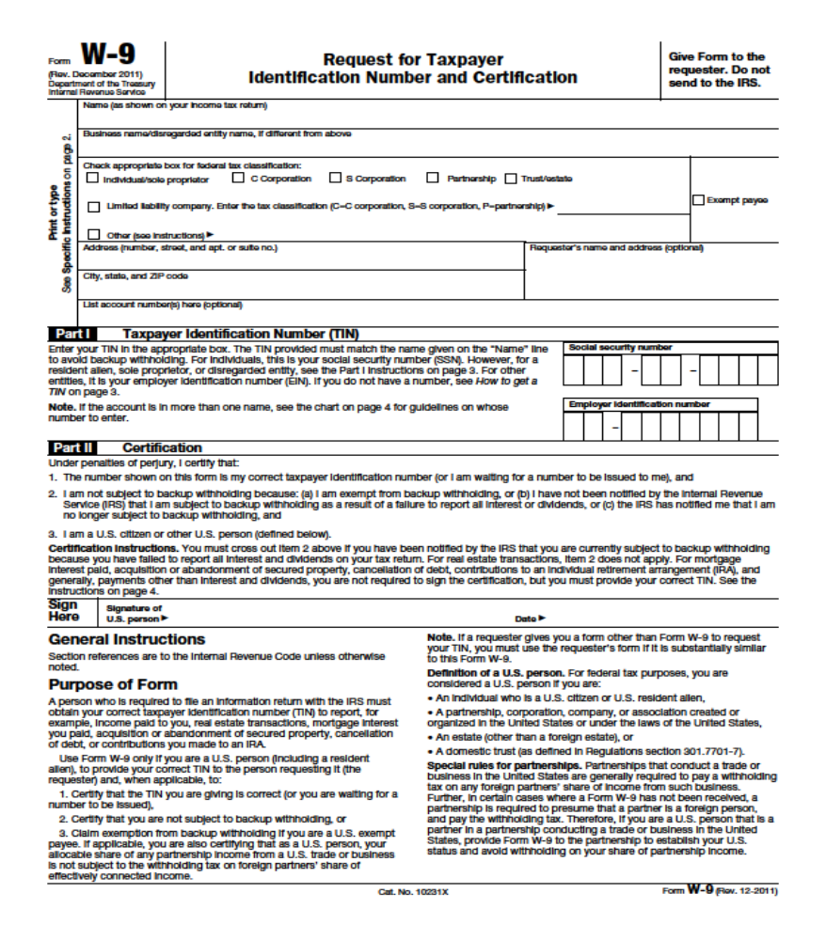

VENDOR INFORMATION
No payments will be made by The University of Louisiana at Monroe until the following vendor information is provided. This information will also be utilized by ULM’s Controller’s Office for preparation of IRS Form 1099. If a Joint Venture contract, the Federal Employer Identification Number for the Joint Venture will have to be supplied for compliance with IRS requirements. Return to the Purchasing Department – Fax: 318-342-5218.

TELEPHONE NUMBER INCLUDING AREA CODE: _____________________________

FAX NUMBER INCLUDING AREA CODE: ______________________________

EMAIL ADDRESS: ______________________________

LOUISIANA SALES TAX NUMBER: ______________________________

SOCIAL SECURITY NUMBER OR FEDERAL EMPLOYER IDENTIFICATION NUMBER:

SSN:__________________________ TAX ID:_____________________________________

COMPLETE FORM W-9 (REQUEST FOR TAXPAYER IDENTIFICATION NUMBER AND CERTIFICATION CONTACT PERSON:

* * * * * * * * *

INCORPORATED: ______YES ______NO

PLEASE PROVIDE NAME AND ADDRESS BELOW:

_____________________________________________________________________________

